Union Valley Wellness Center
Dove Yu, DACM, L. Ac., Dipl. O. M., RD, LE

New Patient Health History

Patient Information

Last Name: First Name: Middle:
Address:
City: State: Zip:
Male/Female Date of Birth: Age:
Phone: Home / Work / Cell Email:
Employment Status: Full Time / Part Time / Self-employed / Retired / Unemployed / Student
Occupation: Address:
Marital status: Married/Single/Divorced/Other
Emergency contact: Relationship: Phone:
Referred by:

Primary Care Physician

Physician Name: Phone:

Name/Address of Clinic/Hospital:

Medical Insurance Status
Insurance Company: Policy Holder Name: Relationship to Patient:

Insurance Company Address: Phone:

Policy/ID Number: Group Number:

General Health and Treatment History
Chief Complaint – what health issue would you like to address? Date of injury or onset of illness

What makes it better? What makes it worse?

Have you been treated for this issue? Please describe.

Have you ever had acupuncture before? If so, when and for what condition(s)?

Do you have other health concerns which are being treated currently? Please list and describe.

Are you on a special or restricted diet? (e.g. Diabetic, Low Sodium, Vegetarian, Vegan, Low Calories, etc.)

How many glasses of water do you drink?
Do you exercise regularly? If yes, please describe type of exercise. How often and how long?

Medications/Herbs/Supplements (Please list any you are taking currently)
Medications: Herbs: Vitamins/Supplements:

List of known Drugs or Food Allergies
Drug Allergies: Food Allergies:

Habits (Please check any that apply to you, current or past)
Coffee: C/P Tobacco: C/P Alcohol: C/P Marijuana: C/P |  | Age quit:

Major Hospitalization
Year Surgeries/Illness Hospital City/State

Pregnancy History
Are you pregnant now: Y/ N If yes, for how long?
Total Number of Pregnancy:
# Living: # Ectopic: # Miscarriage: # Induced Abortion:

Family Health History (Place X where applicable)
 | Self | Family  Members |  | Self | Family Members
Allergies |  |  | High Blood Pressure
Blood Disorder/Blood Thinners |  |  | High Cholesterol
Autoimmune Disease |  |  | Heart Disorder / Pacemaker
Cancers or Tumors |  |  | Kidney / Bladder Disorder
Depression / Mental Illness |  |  | Seizure Disorder
Diabetes (Type 1/2) |  |  | Stomach / Intestinal Disorder
Drug / Alcohol Abuse |  |  | Stroke
Fainting Disorder |  |  | Tuberculosis
Family Member Age at Death |  |  | Other

Please check all symptoms that you have currently
General  - Chill / fever  - Cold hand / feet  - Feverish / flushes in the afternoon  - Heat sensation in hands / feet / chest  - Night sweat  - Sweats easily during daytime | Hepatic  - Anger easily  - Bloodshot eyes / dry eyes  - Blurred vision / Poor night vision  - Brittle nail  - Cataracts / Glaucoma  - Dizziness / vertigo  - Floating black spots  - Grinding teeth  - Headaches  - Hypochondriac pain  - Irritable, frustration  - Muscle spasms, twitching, cramping  - Numberless/tingling of limbs  - Paralysis  - Seizures/tremors / convulsions  -------------------------------------------------  - Gall stone | Respiratory  - Asthma / Bronchitis  - COPD / Emphysema  - Cough / chest congestion  - Dry mouth/thirst  - Frequent / lingering colds  - Hay fever / allergies  - Sadness / grief  - Short of breath  - Sinus congestion / infection  - Sore throat
Cardiovascular  - Anxiety  - Bitter taste in mouth  - Chest Pain  - Depression  - Easily startle  - Insomnia  - Irregular heart rate  - Palpitations  - Restlessness  - Sores on tongue  - Excessive dream |  | Men Only  - Genital lesions / discharge  - Ejaculatory problems  - Impotence / erectile dysfunction  - Pain or swelling of testicles  - Pain or itching of genital
Gastro/Intestinal  - Abdominal bloating or gas  - Bruises easily  - Confused with fuzzy head  - Constipation/Diarrhea/Alternate  - Edema of body  - Feeling tired / burning sensation after eating  - Heavy body sensation  - Over thinking  - Poor appetite  - Mental heaviness / fogginess  - Prolapsed organs  - Weak muscle  -------------------------------------------------  - Bad breath  - Bleeding, Swollen /painful gums  - Heart burn / Belching  - Large appetite  - Mouth canker / cold sores  - Nausea / Vomiting / Hiccup  - Stomach pain before or after eating | Renal/Urinary  - Decreasing hearing  - Fearful feeling  - Frequent urination during the day  - Hair brittle/thinning / loss  - Hot flashes  - Kidney stone  - Lack of motivation  - Low back Pain  - Memory loss  - Noctouria  - Ringing in the ear  - Sore/cold / weak knees  - Libido: Normal / Low / High  -------------------------------------------------  - Burning / difficult/painful/urgent urination  - Lack of bladder control  - Urine color:  Normal / Clear/Dark / Yellow /  Reddish / Cloudy | Women Only  - Average # of days in flow:  - Regular menses cycle: Yes/No  - Red / Dark / Purple color  - Normal/Heavy/Light flow  - Menstruation related symptoms?  - Bleeding between periods  - Blood clots  - Breast distension  - Cramps  - Heavy vaginal discharge between periods  - Nausea  - PMS  - Birth control: Yes / No

Indicate painful areas and rate pain on a scale of 1 (No pain) to 10 (Worst pain).
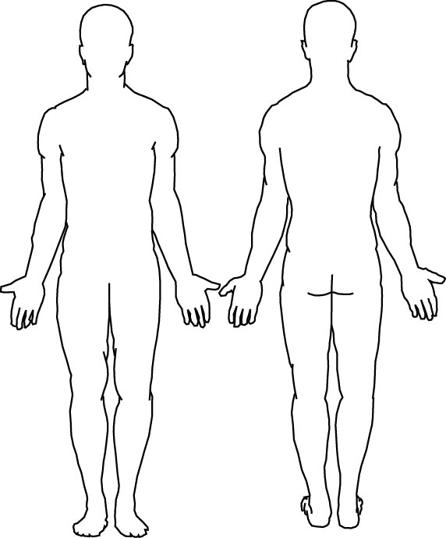
Union Valley Wellness Center
Dove M Yu, DACM, L. Ac., Dipl. OM, RD, LE
Informed Consent Treatment Agreement

I consent to receive acupuncture and related treatments by Dove M. Yu, L. Ac. Treatment methods may include, but are not limited to, Acupuncture, Cupping, Electrical Stimulation, Guasha, Herbal Medicine, Moxibustion, Tui Na massage bodywork (Manual Therapy) and Nutritional Counseling.

I have been informed that acupuncture is safe, but it may have side-effects, including bruising, numbness or tingling near the needling sites that may last a few days, and, in rare cases, dizziness or fainting. Unusual risks of acupuncture include spontaneous miscarriage, nerve damage, and organ puncture. Infection is also a possible risk. However, I understand the practitioner uses only sterile, disposable needles, and maintains a clean and safe environment. Bruising is a common side effect of cupping and guasha. Burns and scarring are potential risks of heat or moxibustion. Mild muscle discomfort may be experienced with electro stimulation. Tui Na massage therapy is safe but may lead to temporary muscle soreness.

The herbs and nutritional supplements used in Chinese Medicine are considered safe but may have potential side effects. I understand that some herbs may be toxic at large doses, and some herbs may be inappropriate to take during pregnancy. Some possible side effects of taking herbs are changes in bowel movements, abdominal pain/discomfort, nausea/vomiting, rashes and tingling of the tongue. I will notify my acupuncturist immediately if I notice any side effects associated with the consumption of herbal medicine or nutritional supplements.

I do not expect the practitioner to be able to anticipate and explain all possible risks and complications of treatment. I wish to rely on her to exercise judgment during course of treatment to make decisions that are in my best interest based on the facts then known. I will notify the practitioner if I am or become pregnant.

I understand that the clinical and medical staff may review my medical records and lab reports, but all my records will be kept confidential and can only be released under my personal written consent, or when required by law.

If I am unable to make my appointment, I agree to reschedule or cancel with at least 24 hours advanced notice. I understand that failure to do so, a $25 service fee will be charged. I also understand that if I am more than 15 minutes late to an appointment, my treatment will be adjusted to the reminding time allowed.

I understand that the practitioner has the right to refuse treatment to any patient at any time. Reasons for refusal of treatment include crude behavior or inappropriate conduct.

By voluntarily signing below, I show that I have read (or have had read to me) and understood this consent to treatment. I have been told about the risks and benefits of acupuncture, related therapies, and have had an opportunity to ask questions. This consent form shall cover the entire course of treatment for my present condition and for any future conditions for which I seek treatment.

____________________________________________ __________________________________________ Print Name of Patient (or Representative) Print Name of Practitioner

X___________________________________________ X_________________________________________
Signature of Patient (or Representative) Signature of Practitioner

____________________________________________
(Print Name of Translator)

X__________________________________________ ___________________________________________
(Signature of Translator) Today’s Date

- Confidentiality: Your patient records and information will be kept strictly confidential and will only be shared when necessary to provide your care, or under your written authorization, or required by law.

